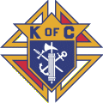
KNIGHTS OF COLUMBUS
Precious Blood of Christ Council 11028
1633 Waverly Road
Pawleys Island, SC 29585

